# Electrical Principles and analytical methods.

Student ID No: 18026826

Name: Benjamin Samuel Edwards

# Introduction:

For this assignment I have been tasked with creating a variety of simulations of electronic circuits using MATLAB and Simulink. The first task was to show a 3D graph comparing the Voltage across R2 with the resistance of the changing variable resistor R4 and the changing voltage source. Secondly, simulations of RLC circuits would be made comparing the current against time of one and the change of inductance compared to the change in capacitor voltage. Thirdly an OP amp circuit will be simulated comparing Vout and Vin against time t. and finally, Simulink will be used to build two closed loop systems that will plot the speed response for one and the response curve for the final system.

# Q1

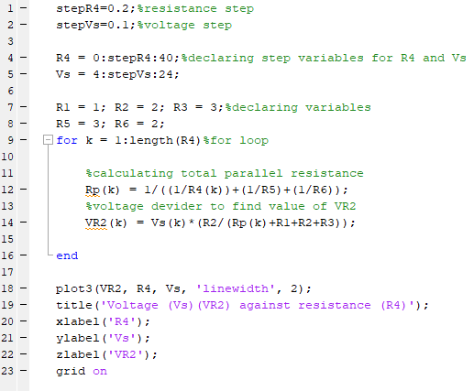

Figure 1.1

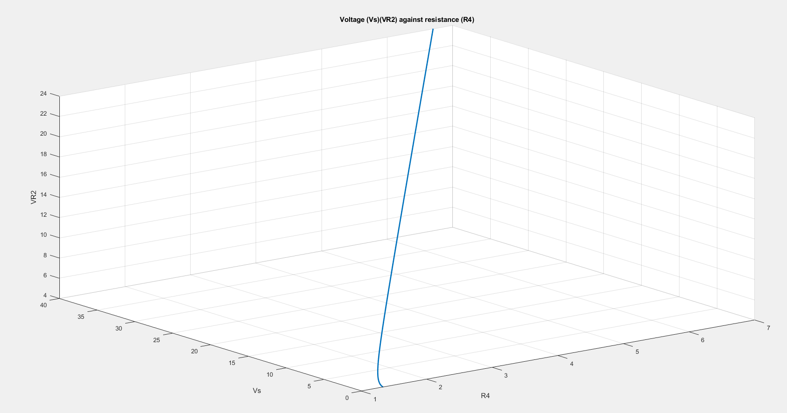

Figure 1.2

# Q2

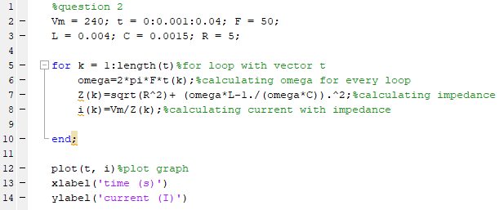

Figure 2.1

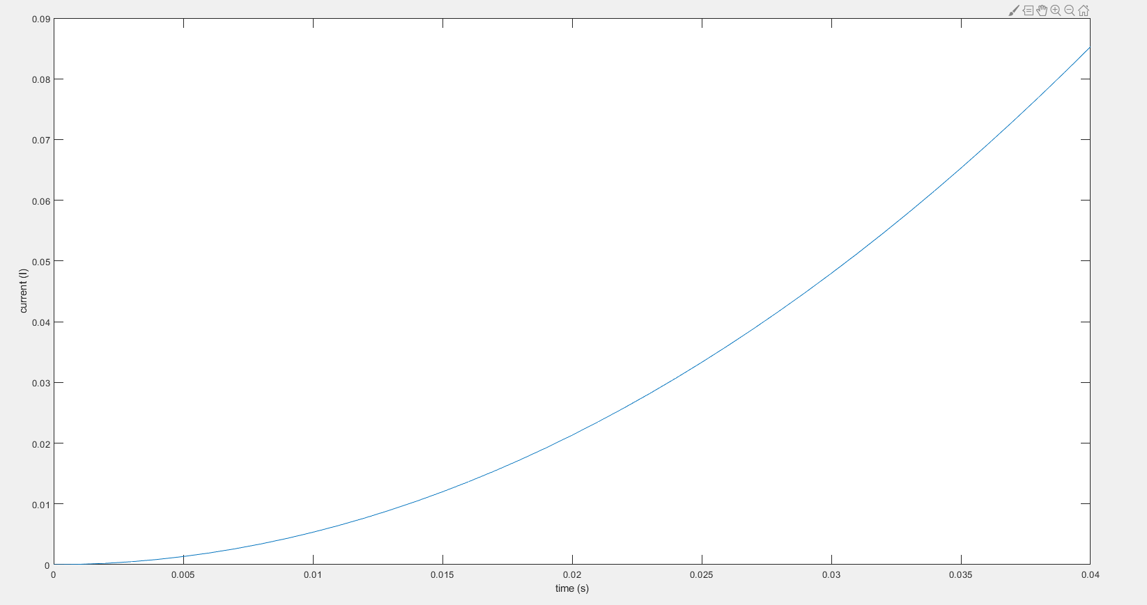figure 2.2

# Q3

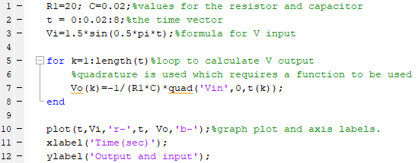

Figure 3.1

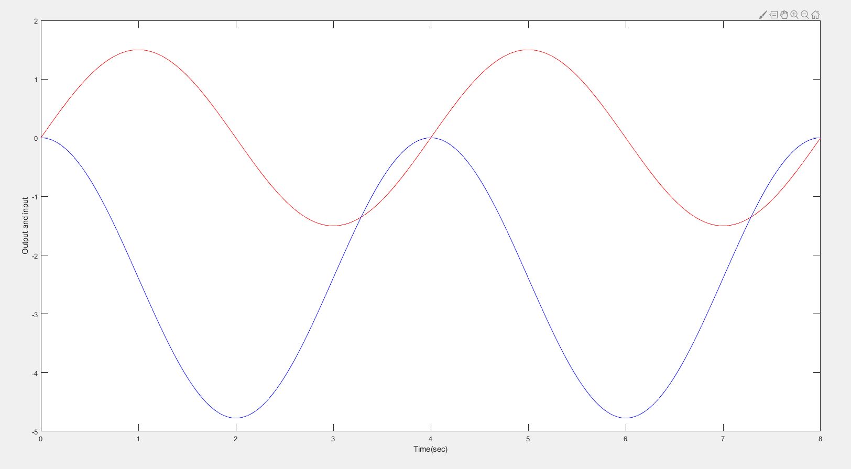

Figure 3.2

# Q4

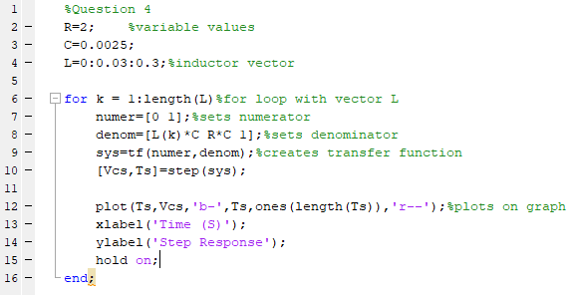figure 4.1

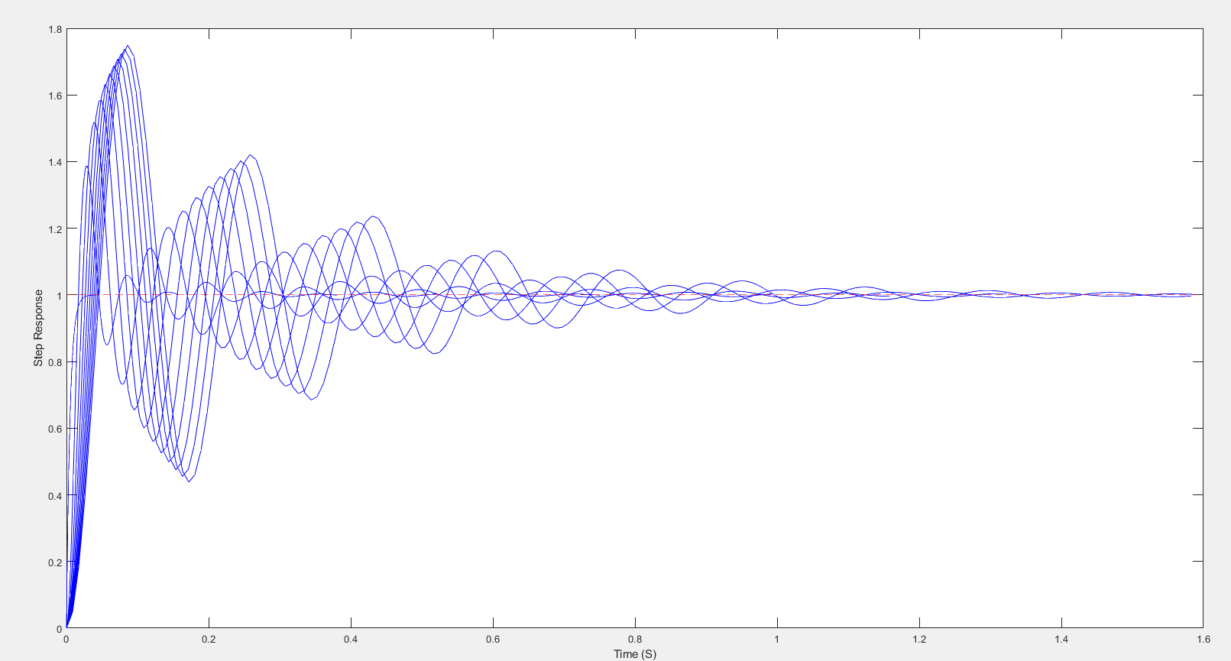figure 4.2

# Q5

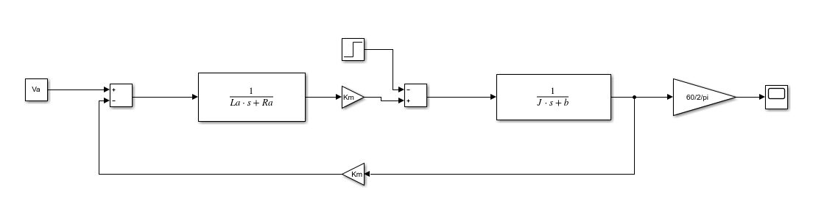figure 5.1

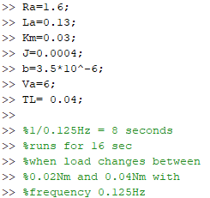

Figure 5.2

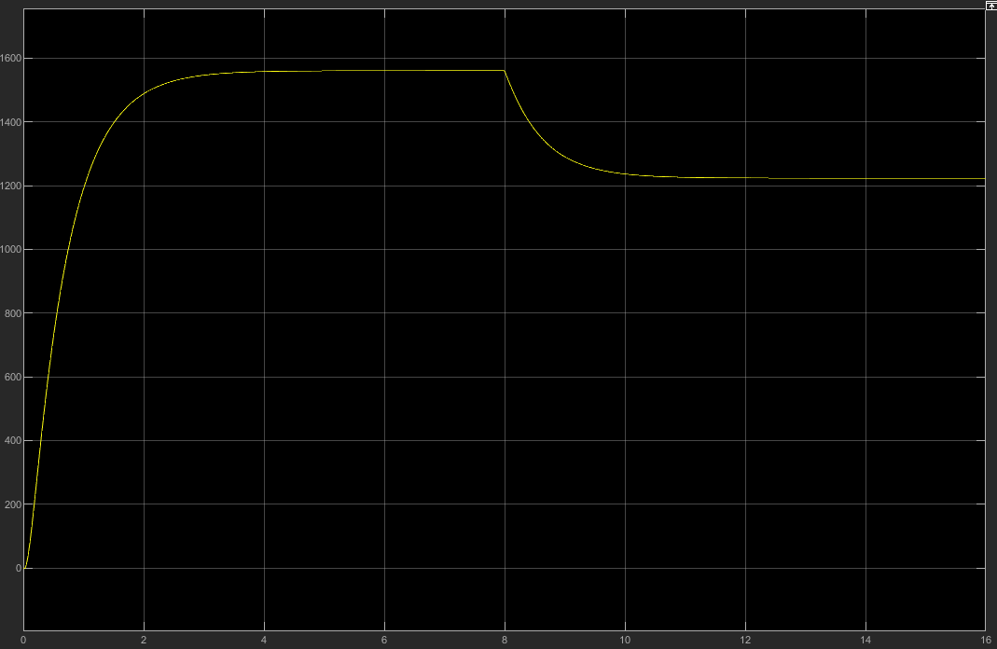

Figure 5.3

# Q6

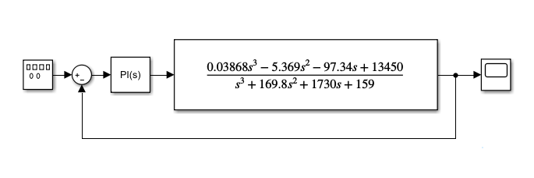

Figure 6.1 **[1]**

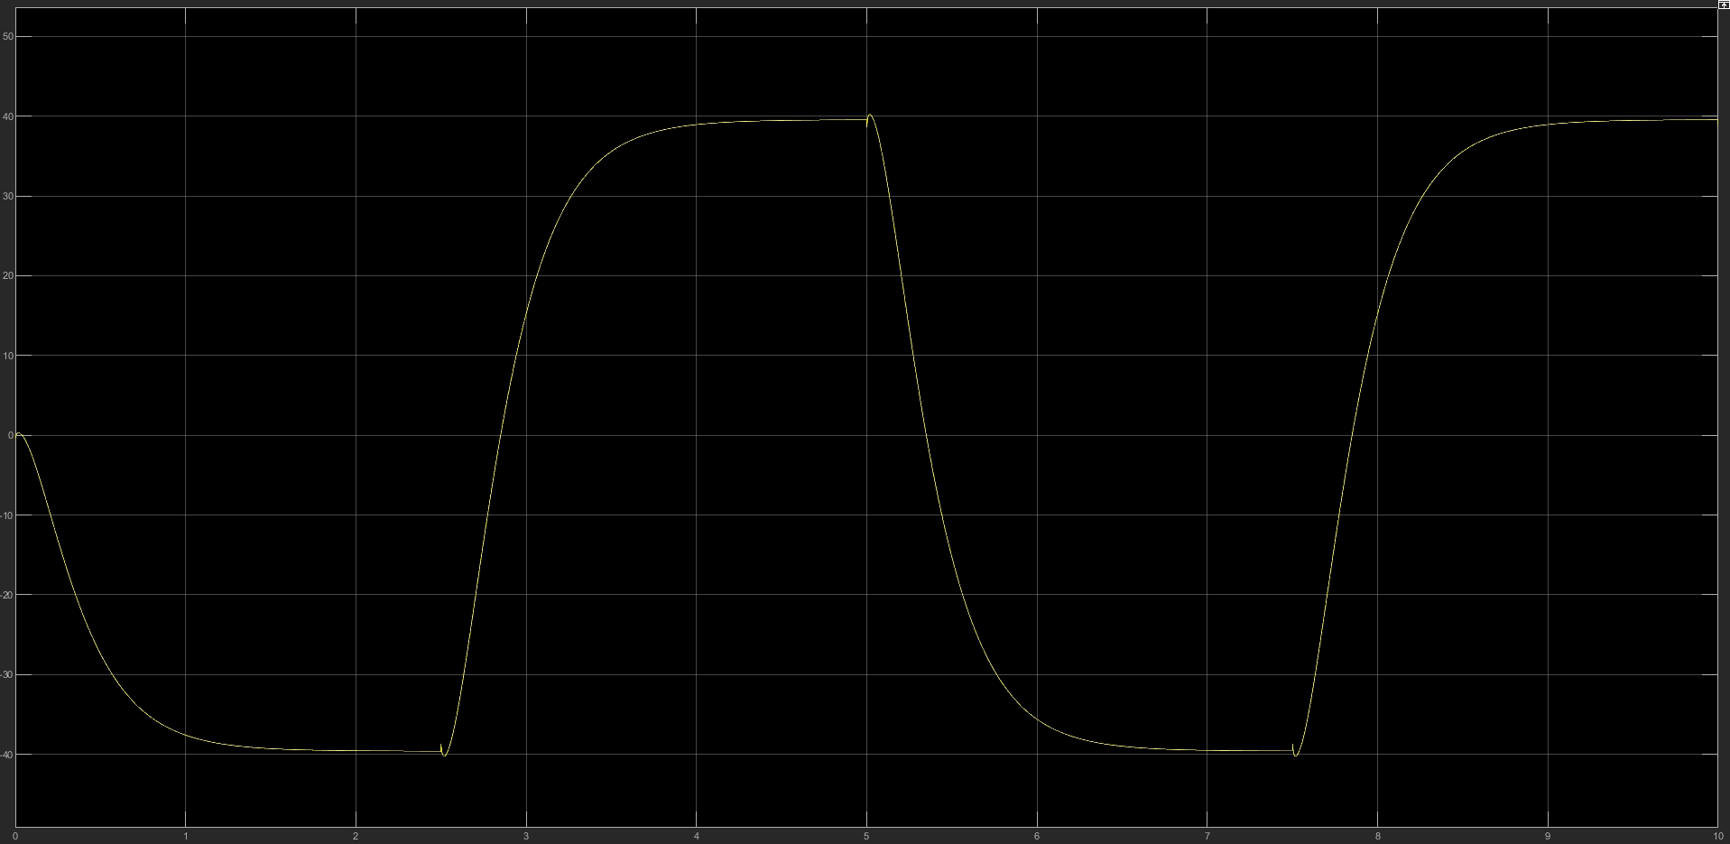

Figure 6.2

# MATLAB Code:

## Q1

stepR4=0.2;%resistance step

stepVs=0.1;%voltage step

R4 = 0:stepR4:40;%declaring step variables for R4 and Vs

Vs = 4:stepVs:24;

R1 = 1; R2 = 2; R3 = 3;%declaring variables

R5 = 3; R6 = 2;

for k = 1:length(R4)%for loop

%calculating total parallel resistance

Rp(k) = 1/((1/R4(k))+(1/R5)+(1/R6));

%voltage devider to find value of VR2

VR2(k) = Vs(k)*(R2/(Rp(k)+R1+R2+R3));

end

plot3(VR2, R4, Vs, 'linewidth', 2);

title('Voltage (Vs)(VR2) against resistance (R4)');

xlabel('R4');

ylabel('Vs');

zlabel('VR2');

grid on

## Q2

%question 2

Vm = 240; t = 0:0.001:0.04; F = 50;%declaring variables and time

L = 0.004; C = 0.0015; R = 5;

for k = 1:length(t)%for loop with vector t

omega=2*pi*F*t(k);%calculating omega for every loop

Z(k)=sqrt(R^2)+ (omega*L-1./(omega*C)).^2;%calculating impedance

i(k)=Vm/Z(k);%calculating current with impedance

end

plot(t, i)%plot graph

xlabel('time (s)')

ylabel('current (I)')

## Q3

R1=20; C=0.02;%values for the resistor and capacitor

t = 0:0.02:8;%the time vector

Vi=1.5*sin(0.5*pi*t);%formula for V input

for k=1:length(t)%loop to calculate V output

%quadrature is used which requires a function to be used

Vo(k)=-1/(R1*C)*quad('Vin',0,t(k));

end

plot(t,Vi,'r-',t, Vo,'b-');%graph plot and axis labels.

xlabel('Time(sec)');

ylabel('Output and input');

## Vin

%Calculates function value at x

function [V]=Vin(x)

%function expression

V=1.5*sin(0.5*pi*x);

end

## Q4

%Question 4

R=2; %variable values

C=0.0025;

L=0:0.03:0.3;%inductor vector

for k = 1:length(L)%for loop with vector L

numer=[0 1];%sets numerator

denom=[L(k)*C R*C 1];%sets denominator

sys=tf(numer,denom);%creates transfer function

[Vcs,Ts]=step(sys);

plot(Ts,Vcs,'b-',Ts,ones(length(Ts)),'r--');%plots on graph

xlabel('Time (S)');

ylabel('Step Response');

hold on;

end;

# References

1. Michael Carone, Priyanka Gotika, M.C , P.G. 2020. Mathworkscom. [Online].[11 May 2020]. Available from: <https://www.mathworks.com/videos/getting-started-with-simulink-part-2-adding-a-controller-and-plant-to-the-simulink-model-1508442594866.html>